ETE Reman User Guide

Create New Company
Steps:
1. Open Magento Admin Panel - http://Your Domain Name/index.php/admin/;
2. Enter your Name and Password:
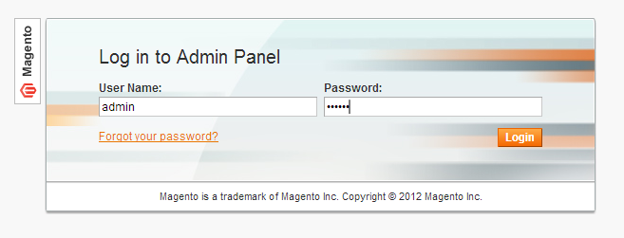
3. Select Customer link from the top menu and then select "Manage Companies" link:
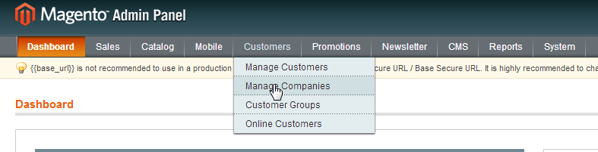
4. In the opened page you can manage already created Companies and Create new Company. In order to create a New Company press on "Add Company" button in the right top corner:
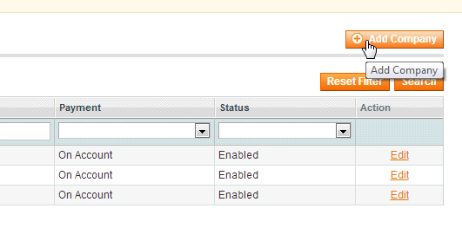
5. In the opened page fill in all necessary fields for General, Address and Warranty pages:
General:
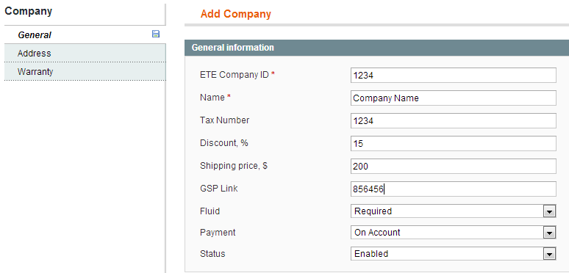
Address:
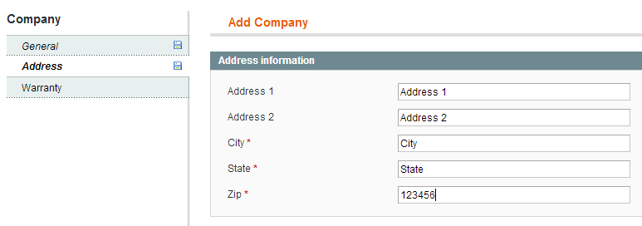
Warranty: Select Warranty type from drop boxes and provide GSW Link if necessary
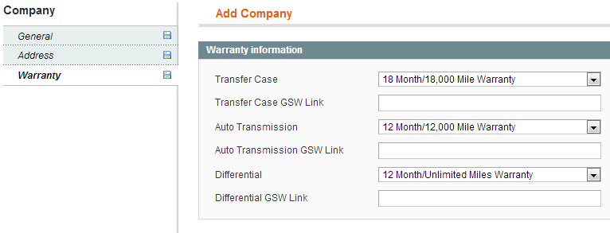

6. After all necessary information is filled in Press "Save Company" button in the top right corner:
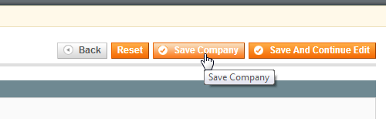
When you are done the page will redirect to Companies List Page where you can add another company or edit existing one.
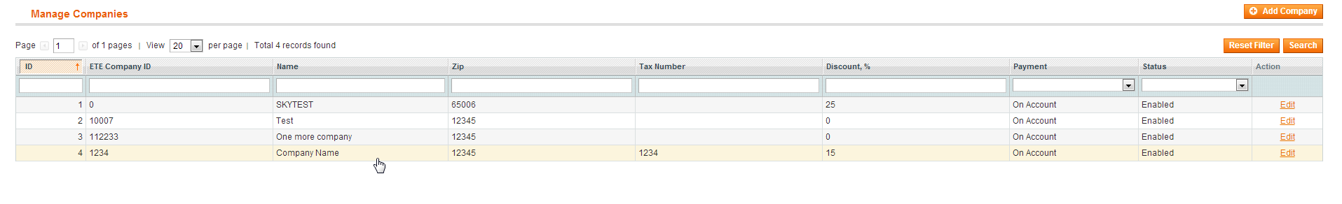

Create New Customer User
Steps:
1. Open Magento Admin Panel - http://Your Domain Name/index.php/admin/;
2. Enter your Name and Password:
3. Select Customer link from the top menu and then select "Manage Customers" link:
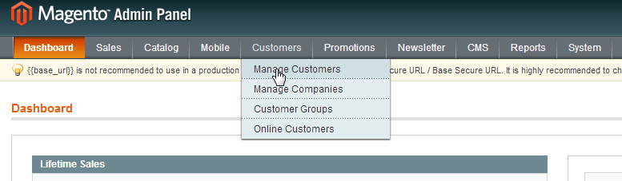
4. In the opened page you can manage already created Customers and Create new Customer. In order to create a New Customer press on "Add New Customer" button in the right top corner:
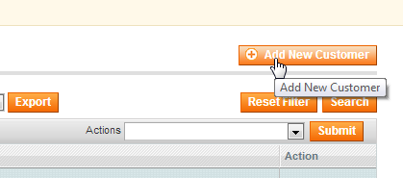

4. In the opened page fill in all neccessary fields for Account Information:
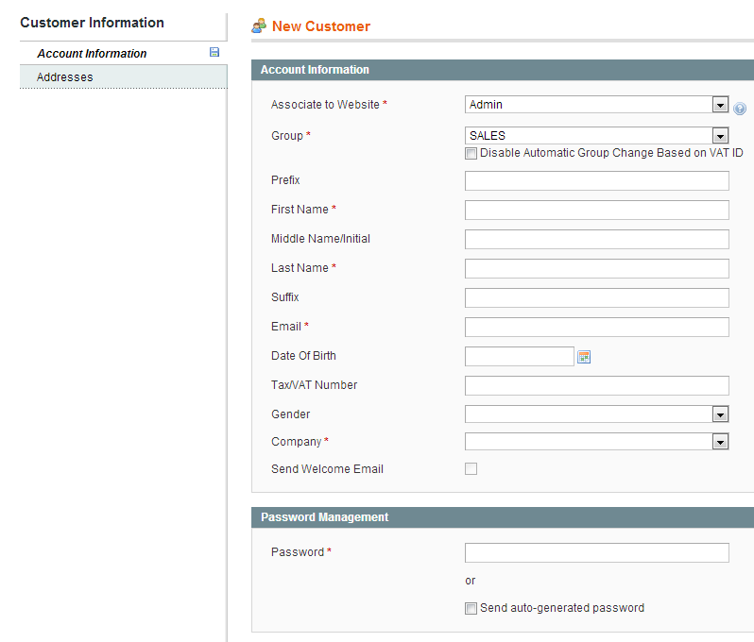
Fields Explanation:
1. Associate to Website: Main Website should be selected in order to assign new user to Ete Reman catalog site not to Admin
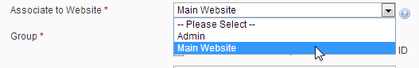
2. Group: New Customer Roles could be assigned here - SALES - have full access to Online Quotes; ADMIN -have full access to Online Quotes and can create new under his company account;
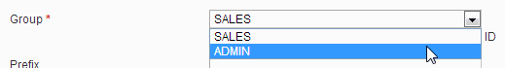

3. Company: Connect New User to Company profile in order to assign all Companies features for this user. So Select necessary Company name from drop box;

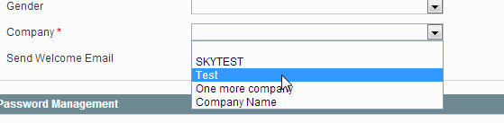
4. Send Welcome Email: If necessary check the select box (Optional)
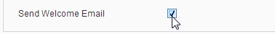

5.Password Management: Assign new password for user or check the auto-generated password select box.
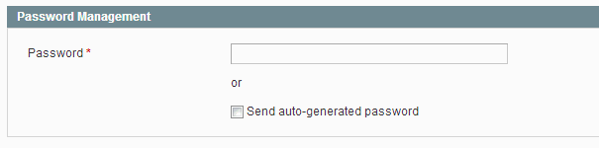

5. When all User information is filled in Press "Save Customer Button" in the right top corner:

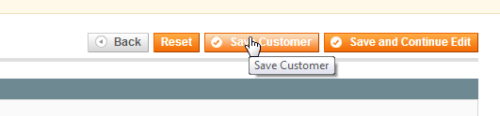

When you are done the page will redirect to Customers List Page where you can add another customer or edit existing one.
